LABO 8 : Blocking Threats using App-ID
8.1 – Apply Baseline Configuration
Load a pre-configured firewall setup via the web interface.
8.2 – Create FTP Service Object & Port-Based Rule
- Create a service object for FTP (TCP/21)
- Create a security policy rule allowing FTP from Users_Net to Extranet
- Test FTP connectivity and verify traffic logs
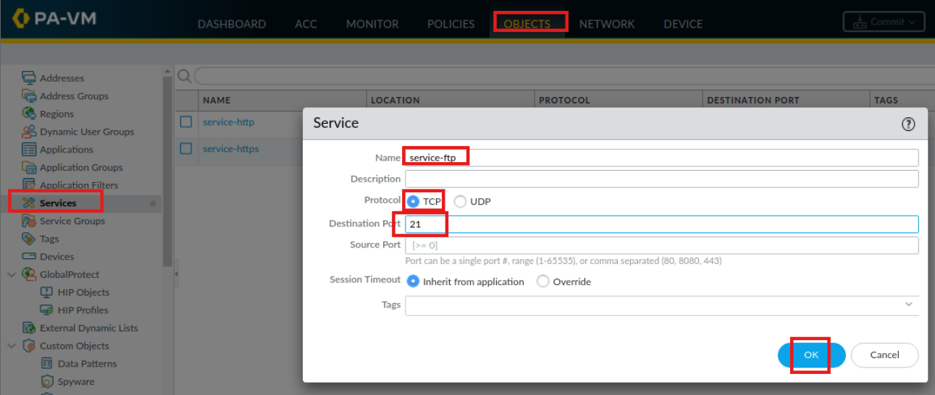
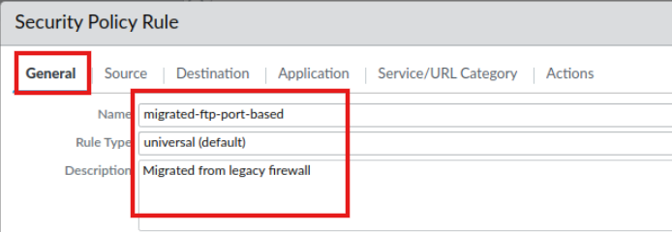

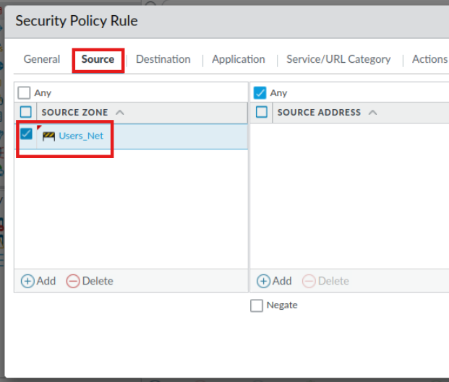
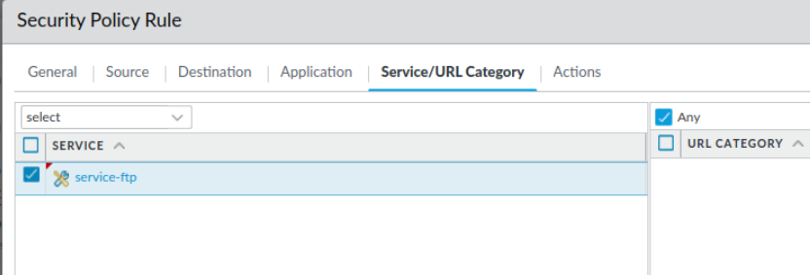
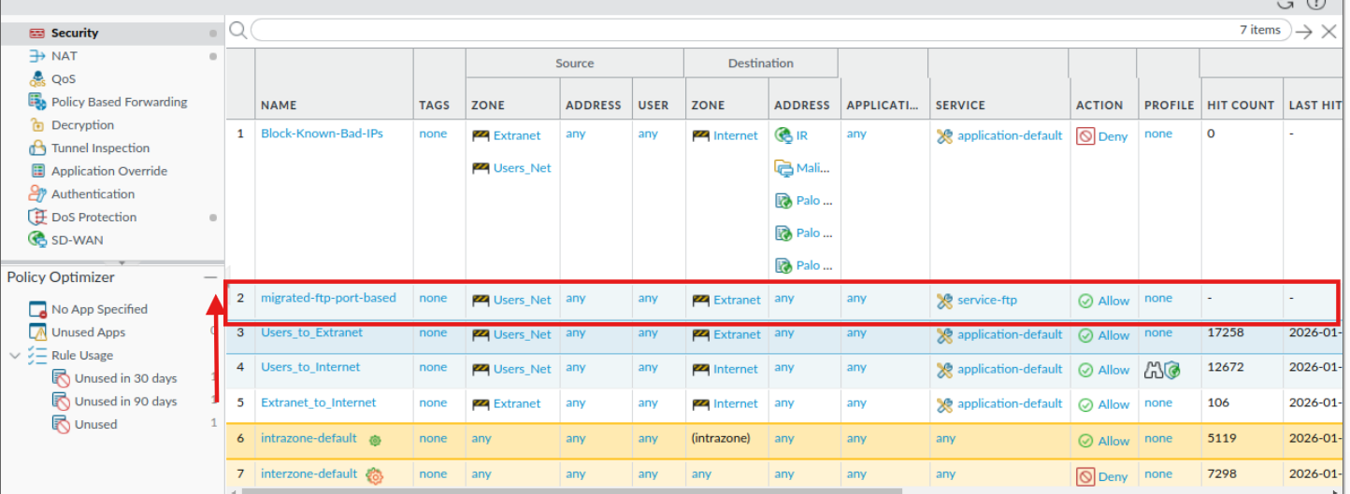

Log in with the username paloalto42 and Pal0Alt0! as the password.
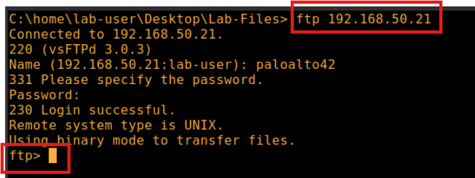
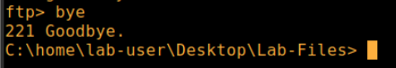
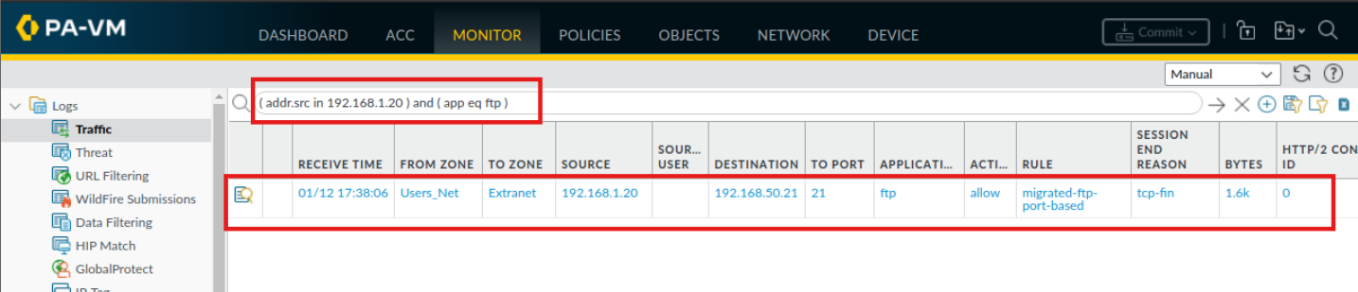
8.3 – Generate Application Traffic
Run a script to simulate various application traffic (DNS, web browsing, social media, etc.).
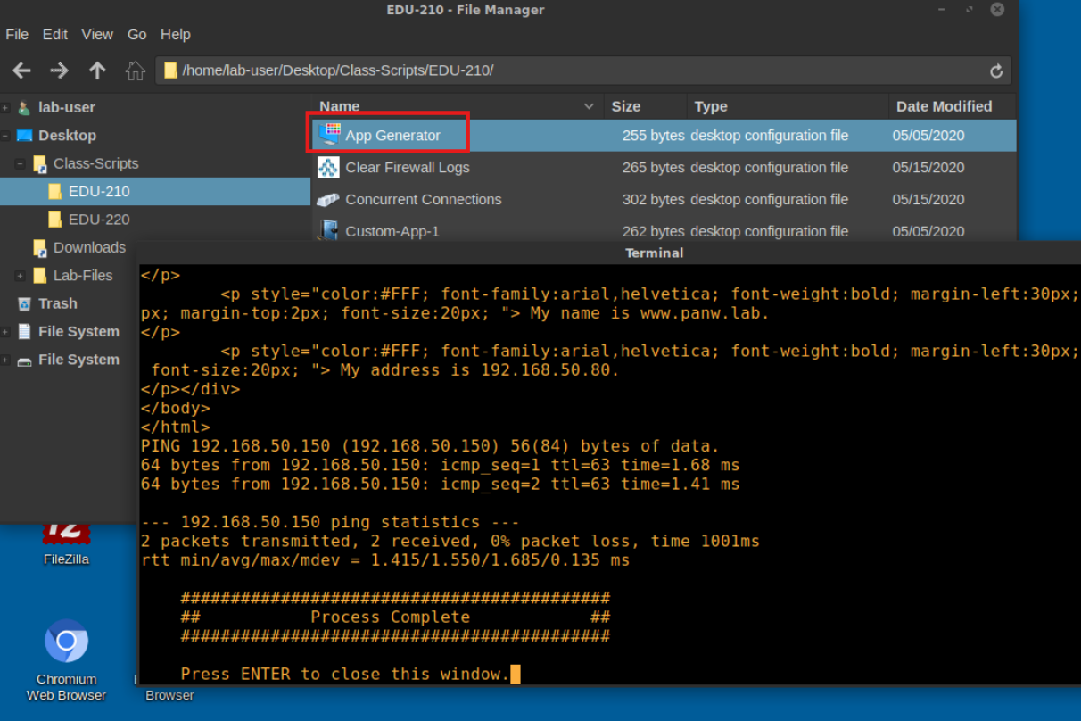
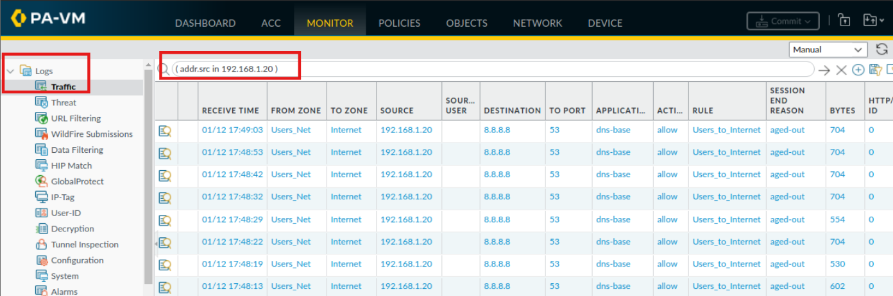
8.4 – Configure an Application Group
Create an application group named paloalto-apps containing Palo Alto-specific applications:
- paloalto-updates
- paloalto-dns-security
- paloalto-wildfire-cloud
- pan-db-cloud
- paloalto-userid-agent
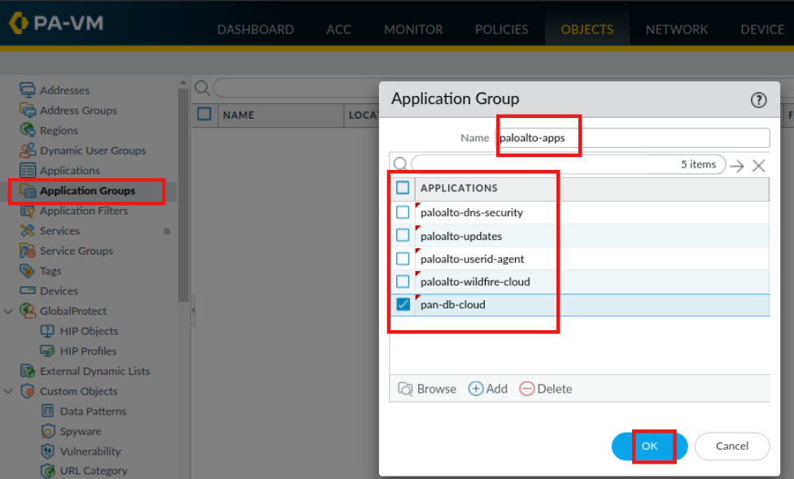
8.5 – Create Security Policy for Update Traffic
Create a rule Allow-PANW-Apps to allow traffic from the firewall (192.168.1.254) to the Internet for the paloalto-apps group.
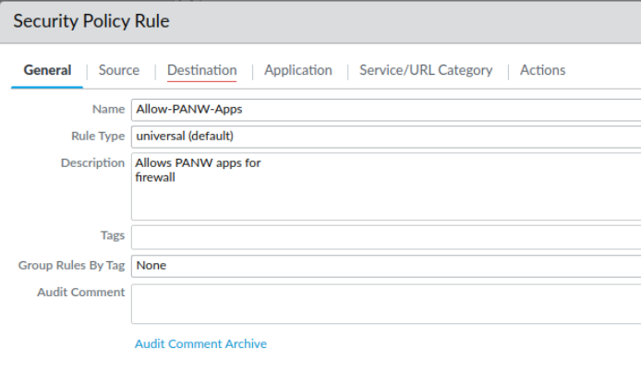
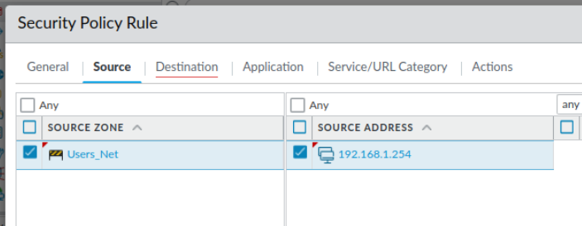
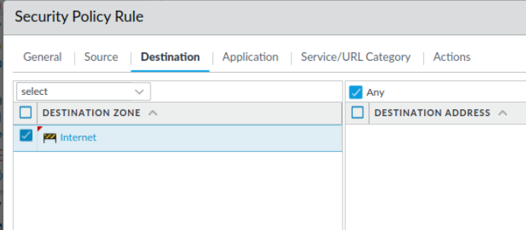
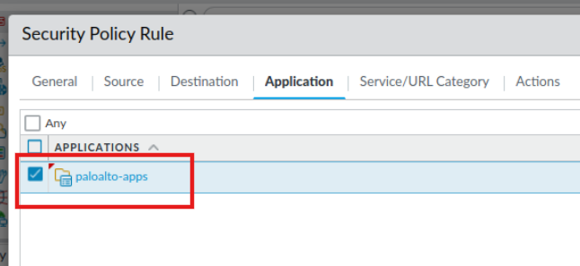
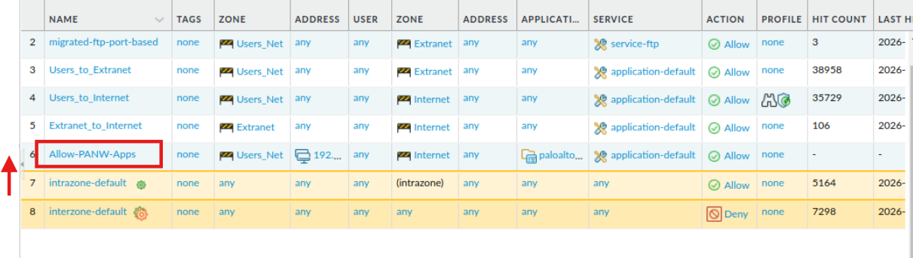
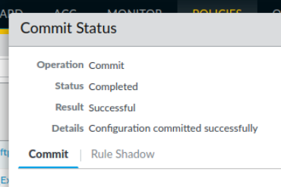
8.6 – Test the New Policy
Check for dynamic updates and observe traffic logs. Notice that the Users_to_Internet rule shadows the new rule.
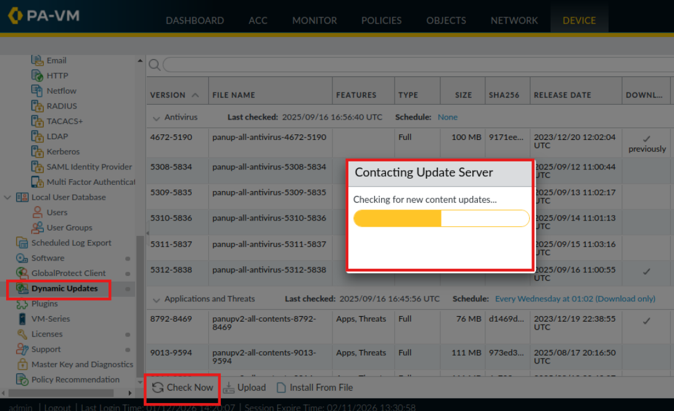
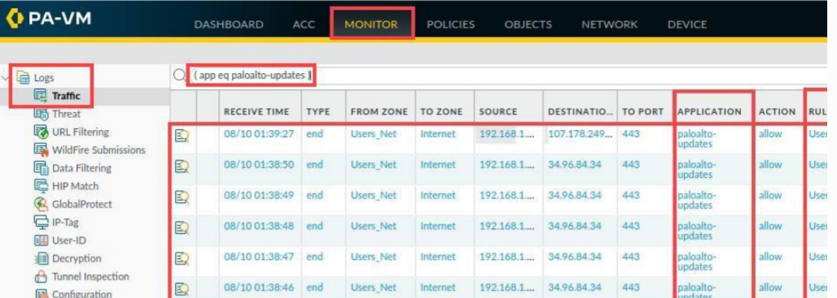
8.7 – Identify Rule Shadowing
Use the Task Manager and Rule Shadow tab to see which rules are being overshadowed.
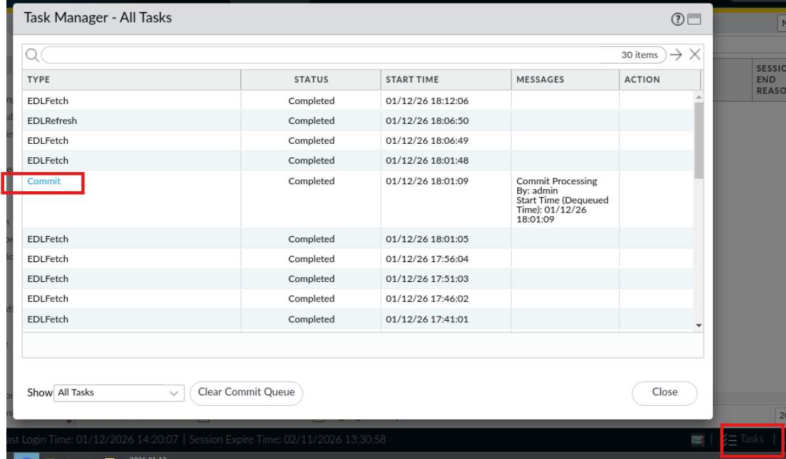
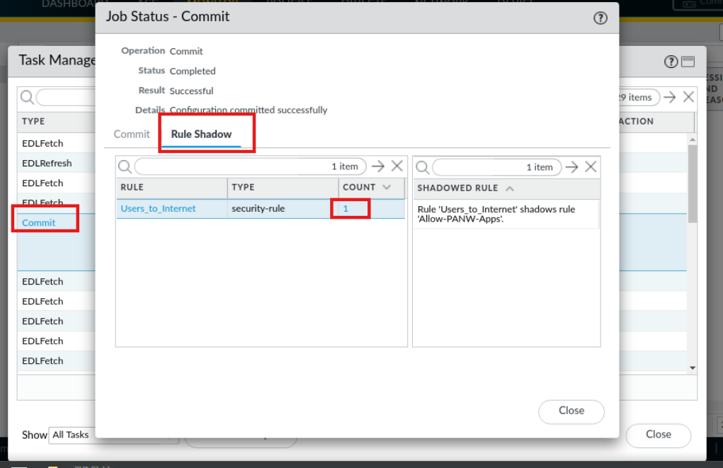
8.8 – Modify Policy for Proper Functionality
Edit the Users_to_Internet rule to allow only specific applications (dns, ping, ssl, web-browsing), preventing it from shadowing Allow-PANW-Apps.
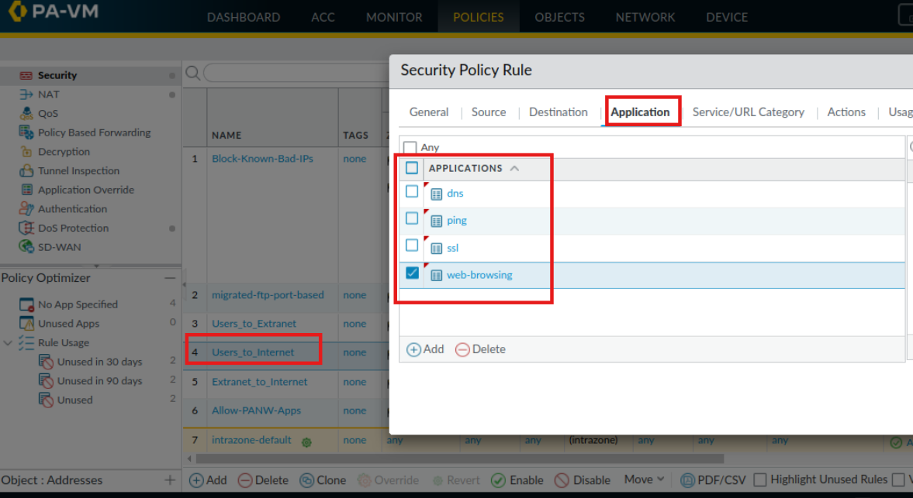
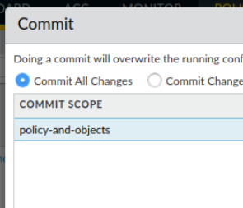
8.9 – Test Modified Policy
Verify that:
- Palo Alto update traffic now uses Allow-PANW-Apps
- General web traffic uses Users_to_Internet
- Both policies work as intended
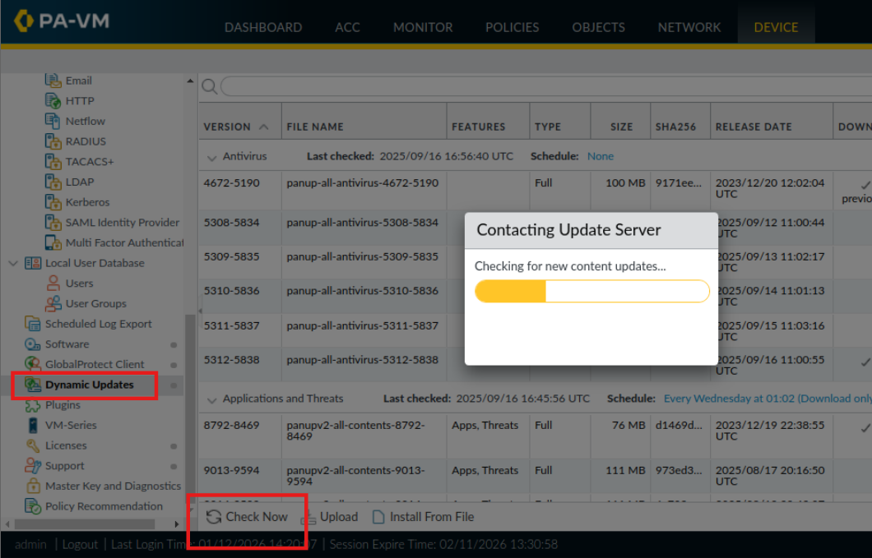

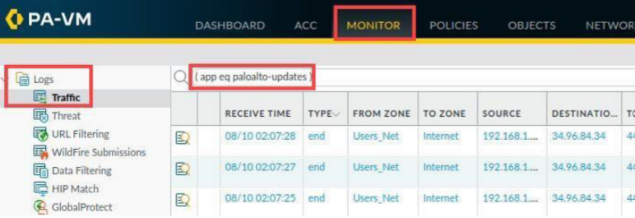
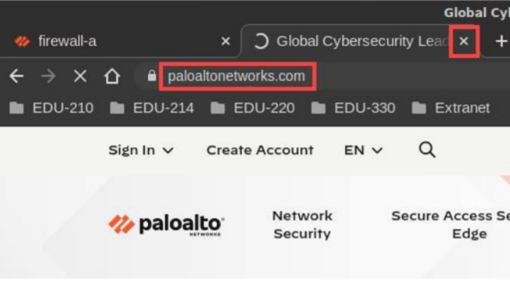
(addr.src eq 192.168.1.20 ) and ( rule eq Users_to_Internet )
